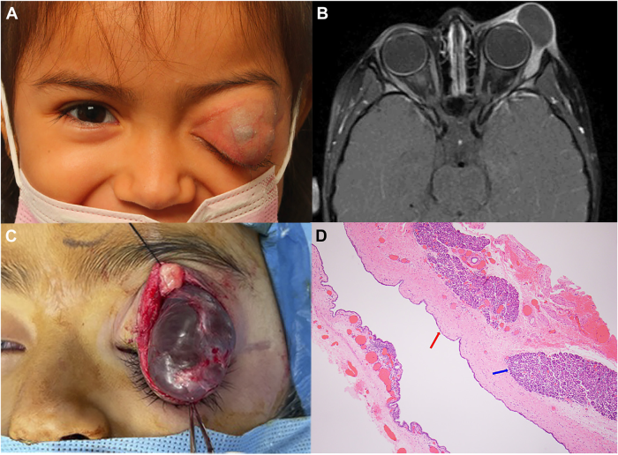

A 4-year-old girl presented with 2 years of painless, intermittent left eyelid swelling with 5 days of acute worsening associated withbluish-gray skin discoloration (A). Orbital magnetic resonance imaging demonstrated a well-circumscribed, thin-walled, rim-enhancingcystic lesion arising from the left lacrimal gland (B). She underwent complete surgical excision (C). Pathology revealed a benignepithelial cyst (D, red arrow) and adjacent normal lacrimal gland tissue (D, blue arrow). Based on the provided images and clinical description please make an ophthalmic diagnosis for this patient. And output the diagnostic conclusions only.

**Lacrimal gland ductal cyst (dacryops)**